Test Case for controller

Requirement to test | Test Data Input | Expected Outcomes | Actual Outcomes
- Respond to changes in model | Run Program | 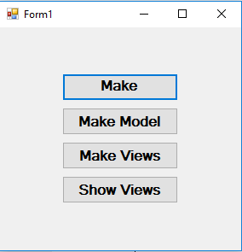 | As expected
 | Run the program and add four objects | 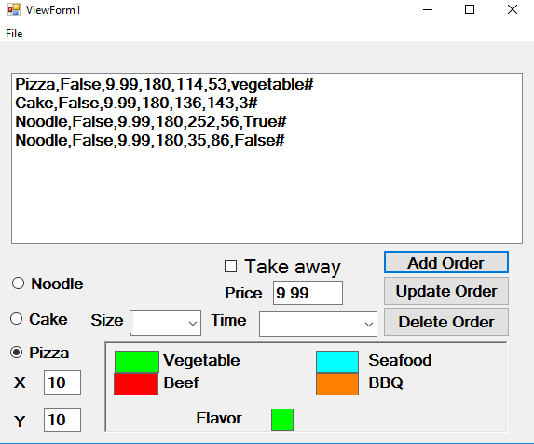 | As expected
 | Select the 3rd objects | 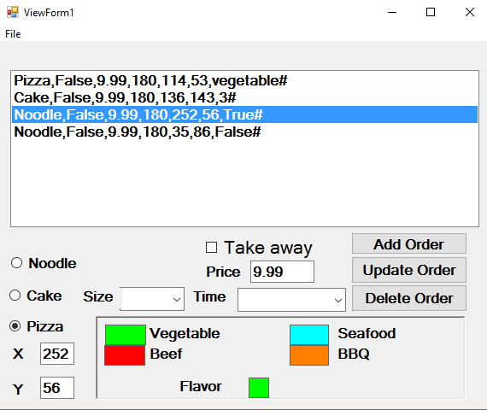 | As expected
 | Change its x and y value to new values,then click “update order” | 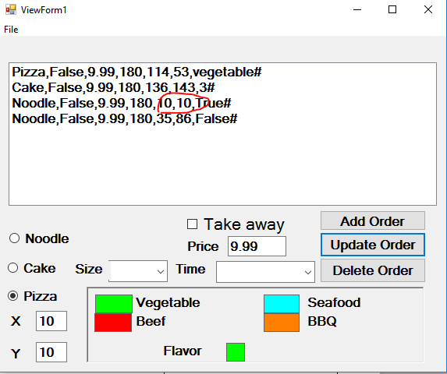 | As expected
- Update all views | Run Program |  | As expected
 | Run the program and add four objects | View 1,view 2 ,view 3 show correctly | As expected
 | Select the 3rd objects |  | As expected
 | Change its x and y value to new values,then click “update order” |  | As expected
 | Change its x and y value to new values,then click “update order” |  | As expected
 |  | Graph in view2 and view 3 have also changed. | As expected

